NEW ENGLAND INSTITUTE OF TECHNOLOGY

Information Technology Department

Quest #2

Design Patterns (GDS 393)
Due: Week #3



Jesse Golembiesky

Developer

7/25/2017

Date

George Saban

Instructor
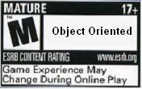



Requirements:

Instructions:
- According to some research, industry values documentation, and excellent written and oral communication skills. The purpose of this part of the class is to encourage you to gain these skills.
- Backup your work to your USB drive for this material may come out as part of your examination.
- Make a copy of this entire document and add your work into it.
- Submit to Canvas at the same link where you got this document.
- Points will be deducted if submitted on the wrong place, or if these instructions are not followed.
- [You can earn a maximum of 30 points for this lab. Refer to the syllabus for late point deductions.]

Problem Statement

Part I: | – Discussion Board.

Please participate and contribute to this week’s conversation in Week #2’s discussion board in Canvas. Do part one first before solving part II. Please do not submit work without completing part I.

Relevance of Design Patterns to 21st Century Workforce
Class discussion: Based upon the last two weeks lecture and materials, what struck you as the most important themes in the ways design pattern idea is translated into 21st Century computing practice? (Provide one posting by creating your thread related to this week’s material and comment to two of your peers).

Part II: | – This will help you familiarize with the Strategy Pattern.

Create your own problem that can be elegantly solved using the Strategy Pattern. In other words, come up with a problem that is solvable using the Strategy Pattern.

- In 200 words or more, write the detailed description of the problem below.

Jimmy is a software engineer for a video game company. His assignment is to write the code for the monsters in a fantasy game. There are monsters that walk on land, monsters that fly, and monsters that swim in the sea. Monsters have different attacks, such as breathe fire, spit acid, cast spells, and attack with a weapon. There are many different combinations of movement and attacks that the monsters can be. Jimmy sees that if he were to use inheritance, there would be a lot of overridden methods. Luckily for Jimmy, he went to his Design Patterns class at NEIT this week and knows how to implement the Strategy Pattern for his assignment. Jimmy will create an abstract class called Monster that has two properties, which are MovementType and AttackType. These are going to be two interfaces, which will be implemented by specific classes. MovementType will be implemented by Walk, Fly and Swim. It has a method called move() that is overridden by these implemented functions to either walk, fly or swim. AttackType has a method called attack() and is implemented by FireBreath, AcidSpit, CastSpell, and SwingWeapon. All of these methods override attack() and do their own unique attack. Now, there are many different classes that extend the abstract Monster class. The Ogre class has an AttackType of SwingWeapon and a MovementType of Walk. The Harpy class has an AttackType of CastSpell and a MovementType of Fly. The Dragon class has an AttackType of FireBreath and a MovementType of Fly. The Crockolisk class has an AttackType of AcidSpit and a MovementType of Swim. The Siren class has an AttackType of CastSpell and a MovementType of Swim. The Warlock class has an AttackType of CastSpell and a MovementType of Walk. Jimmy is ready to write some code.

- And then, solve the problem by applying the Strategy Pattern. Implement your solution using the Java language.

Alternatively, you may solve the problem shown below.
Use Strategy Pattern when you want to choose from different algorithms at runtime. A good use of the Strategy pattern would be saving files in different formats, running various sorting algorithms, or running various file compression. To keep this quest simple, and focus on the Strategy Pattern, you may have your data to be sorted in an array. Then create various types of sorting algorithm that can be used to sort the data in your array. Example sorting algorithms that can be used at runtime are bubble sort and binary sort. For now, don’t worry about compression algorithms. The bottom line is that these sorting algorithms can then be interchanged at runtime using the Strategy Pattern.

Code Development:
package monsters;

public abstract class Monster {
MovementType movementType;
AttackType attackType;
public Monster(){}
public void move(){movementType.move();}
public void attack(){attackType.attack();}
public MovementType getMovementType() {
return movementType;
}
public void setMovementType(MovementType movementType) {
this.movementType = movementType;
}
public AttackType getAttackType() {
return attackType;
}
public void setAttackType(AttackType attackType) {
this.attackType = attackType;
}
public int getHealth() {
return health;
}
public void setHealth(int health) {
this.health = health;
}
}
package monsters;

public interface AttackType {
public void attack();
}
package monsters;

public interface MovementType {
public void move();
}
package monsters;

public class AcidSpit implements AttackType {

@Override
public void attack() {
System.out.println("Acid Spit!");

}

}
package monsters;

public class CastSpell implements AttackType {

@Override
public void attack() {
System.out.println("Magic Missile Attack!");

}

}
package monsters;

public class FireBreath implements AttackType {

@Override
public void attack() {
System.out.println("Fire Breath!");

}

}
package monsters;

public class SwingWeapon implements AttackType {

@Override
public void attack() {
System.out.println("The monster swings it's sword with full forcess!");

}

}
package monsters;

public class Walk implements MovementType {

@Override
public void move() {
System.out.println("The monster walks toward you!");

}

}
package monsters;

public class Swim implements MovementType {

@Override
public void move() {
System.out.println("The monster swims toward you!");
}

}
package monsters;

public class Fly implements MovementType {

@Override
public void move() {
System.out.println("The monster flies toward you!");

}

}
package monsters;

public class Crockolisk extends Monster {
public Crockolisk(){
movementType = new Swim();
attackType = new AcidSpit();
}
}
package monsters;

public class Dragon extends Monster {
public Dragon(){
movementType = new Fly();
attackType = new FireBreath();
}
}
package monsters;

public class Harpy extends Monster {
public Harpy(){
movementType = new Fly();
attackType = new CastSpell();
}
}
package monsters;

public class Ogre extends Monster {

public Ogre(){
movementType = new Walk();
attackType = new SwingWeapon();
}
}
package monsters;

public class Siren extends Monster {
public Siren(){
movementType = new Swim();
attackType = new CastSpell();
}
}
package monsters;

public class Warlock extends Monster {
public Warlock(){
movementType = new Walk();
attackType = new CastSpell();
}
}
package monsters;

public class runMonster {

public static void main(String[] args) {
Monster eddie = new Warlock();
eddie.move();
eddie.attack();
Monster valerie = new Siren();
valerie.move();
valerie.attack();
Monster jimmy = new Ogre();
jimmy.move();
jimmy.attack();
Monster billy = new Crockolisk();
billy.move();
billy.attack();
Monster wanda = new Harpy();
wanda.move();
wanda.attack();
Monster danny = new Dragon();
danny.move();
danny.attack();

}

}

UML Diagram:
Sorry, I don’t have Visio and Cacoo hasn’t activated a student account for me, please accept Google Drawings for now. Also I’m sorry for the really small text. It was the only way to get all the items on one drawing. If you want I can email the drawing separately.-Jesse

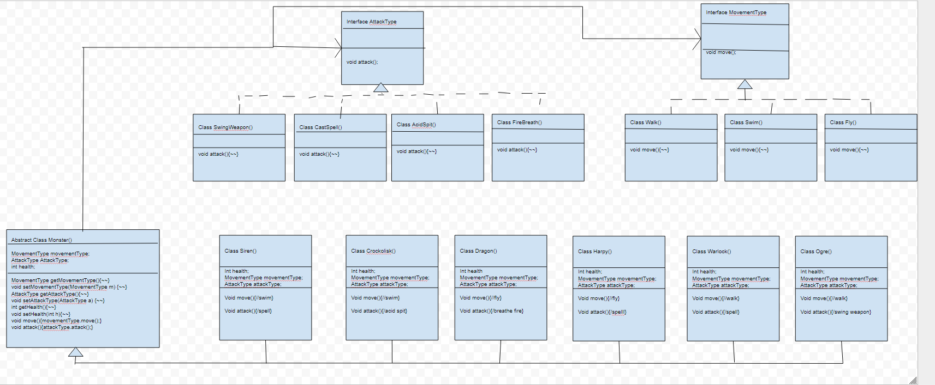

Testing:
What is testing for? Every program you wrote, you are responsible for unit testing it. The first thing to do, once you have a program that “basically works”, is to try to break it. Try to feed your program input(s) in the hope of getting it to misbehave. By “hope” means that the challenge here is to find as many errors as possible, so that you can fix the errors before anybody else finds them. If you go into this exercise with the attitude that “my program works, and I don’t make errors!”, then you won’t find many bugs, and you will feel bad when you do find one or when someone finds one. You’d be playing head games with yourself! The right attitude when testing is, “I’ll break it! I’m smarter than any program--even my own!”
Feed (or try) a few such “problematic” inputs to your program and try to figure out in how many ways you can get it to misbehave. Can you get the program to crash? Testing is a very important part of game development, and can actually be fun. You may input data that is not “sensible”. A program ideally catches all errors, not just the sensible ones--this will make your program resilient against “strange input.”
As a goal, you would like the test to exercise every statement in your program, at least once. Test both positive and negative scenario. One example of positive testing is--if you have an input that requires an integer value, would it work if you give it the numeral 7? Moreover, as an example of negative testing: what happens if you give the previous program a string input of “seven” (instead of the numerical 7)? Identify if your test results are “Passed” or “Failed”. Use the table below, and add at least five test cases of your own!
[Type at least 5 test cases and what was the result? Did the result pass or fail? Do a negative test case too!]
Test # | Test Description | Result  (Passed/Failed)
1 | Create a Warlock, attack and move | Passed
2 | Create a Dragon, attack and move | Passed
3 | Create a Crockolisk, attack and move | Passed
4 | Create a Siren, attack and move | Passed
5 | Create a Ogre, attack and move | Passed
6 | Create a Harpy, attack and move | Passed
7 | Set the Harpy’s health to a String | Failed
 | Add as many rows as needed.

Production Deployment:
[Paste all your own final screens in this section.] Make sure your output screen shot is readable, magnify if necessary so the instructor can easily read it. A sample magnified output is shown below; replace this with your own.
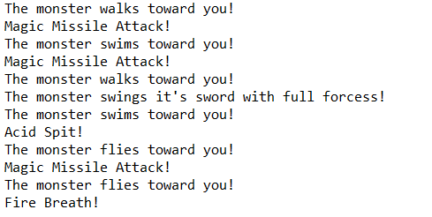
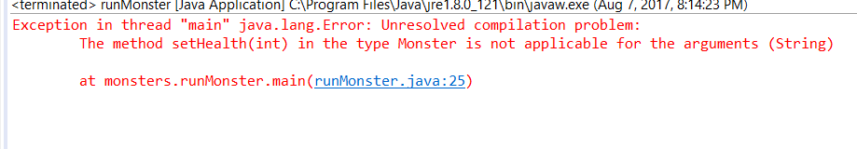

GRADING RUBRIC
Grading Criteria | 3  Exceeds  Excellent  Epic Wow | 2  Meets  Satisfactory  O.K. | 1  Partially Meets  Below Expectations  Not Yet | 0  Does Not Meet  Unacceptable  Fail
Coding | +10-Code is excellent, comments are added, and different techniques were used. | +8-Code is O.K., and program works. | +5-Code works, but still needs improvement. | Unfortunately, no coding.
Output | +5-Outputs are correct, and provided additional output cases. | +3-Output meets requirement and is readable. | +1-There is output, but not readable, and/or needs improvement. | Unfortunately, no output.
Testing | +5-Test cases were excellent, and provided more test cases than what is required. | +3-Provided valid tests, and meets minimum test case requirements. | +1-Test needs improvement, did not make sense, and did not meet minimum test case requirements. | Unfortunately, no testing.
Documentation | +5-Excellent documentation. No misspelling, well formatted, and correct syntax. | +3-Documentation meets requirements. | +1-Documentation has misspelling, or syntax issues, or not clear, or needs improvement. | Unfortunately, no documentation.
Diagram | +5-Excellent diagram. Correct symbols were used and labeled correctly. | +3-Diagram meets requirements. | +1-Diagram does not make sense, or needs improvement. | Unfortunately, no diagram, or diagram was generated.
Late | Excellent, you submitted it before the deadline. | -5, unfortunately for submitting after the deadline. | -10, unfortunately for submitting several weeks after the deadline. | -15, unfortunately, for submitting very late.

